

Names:
Amina Mohsen 231002112
Mohammed negm 231000582
Ouda Mahmoud Salam O.Mahmoud2149@nu.edu.eg

Project name:

Local event finder website
https://github.com/AminaMohsen94/onlinerecruitment-.git
1.
Online Recruitment System Documentation
1. Introduction
1.1 Purpose
The purpose of this project is to develop an online recruitment system that allows job seekers to register, search, and apply for jobs online, while enabling recruiters to manage job postings and applicants efficiently. The system provides a simple and intuitive interface to streamline recruitment for both candidates and recruiters.
1.2 Project Scope
The system allows users to:
- Create accounts, log in/out, and reset passwords.
- Search and view available jobs.
- Apply for jobs (CV upload is a placeholder; actual file upload can be added later).
- Manage job postings (create, edit, delete).
- Track application status and add notes for recruiters.
- Receive placeholder notifications in UI (email notifications can be implemented in future updates).
1.3 Technologies Used
- Frontend: HTML, CSS, JavaScript
- Backend: Flask
- Database: SQLite
- Tools: Git, StarUML
1.4 Intended Audience
- Job seekers looking for opportunities.
- Recruiters and companies managing job postings and applicants.
1.5 References
- Follows Agile principles and best practices for web application development.

2. Overall Description
2.1 Product Perspective
This is a standalone web application providing core online recruitment features. It can be extended later to integrate additional functionalities, such as real CV uploads, email notifications, or AI-based recommendations.
2.1.1 Product Functions
- Job Search: Candidates can search for jobs by title, city, or type.
- Job Management: Recruiters can create, edit, and delete job postings.
- Application Management: View applications, update status, and add recruiter notes.
- Job Application: Candidates can apply to jobs and save drafts.
- Notifications: Placeholder alerts in UI for application submissions and updates.
2.2 User Characteristics
- Technical Skills: Minimal; designed for ease of use.
- Demographics: Job seekers of all levels (students to professionals).
- Access Medium: Desktop, mobile, and tablet devices.
2.3 Constraints
- Secure storage of user credentials.
- CV upload currently a placeholder (actual file handling to be added later).
2.4 Assumptions and Dependencies
- Users have a stable internet connection.
- Email service is optional and can be integrated in future versions.

3. Interface
3.1 Software Interface
- Frontend communicates with backend via RESTful APIs.
- Backend connects to SQLite database using Flask.

4. Functional Requirements
4.1 User: Job Seeker
- Register / Login / Logout / Reset Password.
- Search for jobs and view job details.
- Apply for jobs (CV upload placeholder supported).
4.2 User: Recruiter/Company
- Create, edit, and delete job postings.
- View applicants, track application status, and add internal notes.
- Placeholder notifications in UI for new applications.

5. Non-Functional Requirements
5.1 Reliability
- System uptime of 99% under normal conditions.
5.2 Recoverability
- Daily database backups recommended.
5.3 Performance
- Page load time under 3 seconds under normal conditions.
5.4 Availability
- Accessible 24/7 on desktop and mobile devices.
5.5 Usability
- Simple and intuitive interface for users of all technical levels.
5.6 Maintainability
- Modular code structure (separate Blueprints, models, and templates) for easier debugging and updates

Use case diagram:
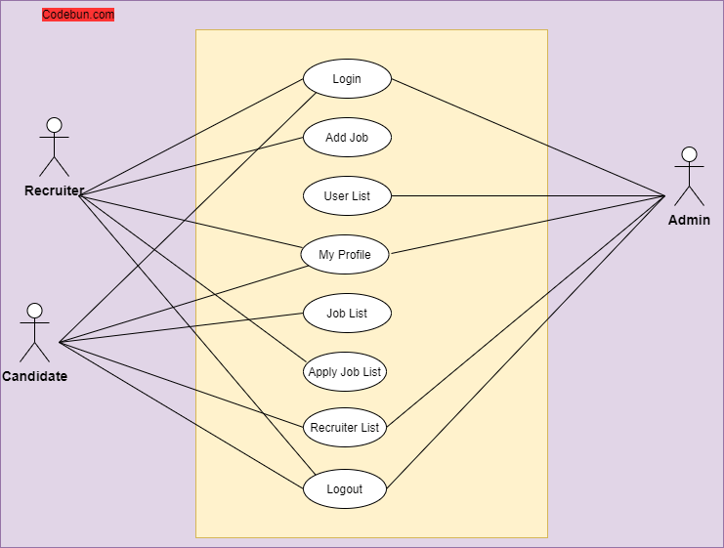

Sequence Diagram:

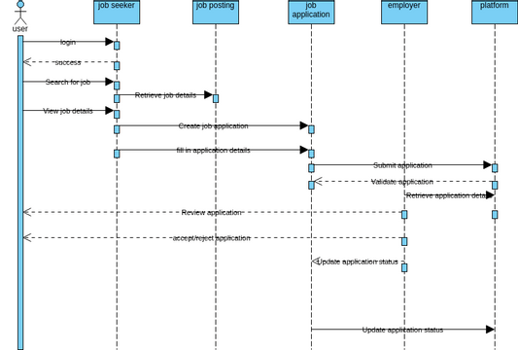

Class Diagram:
